opex meeting chapter
  - January’s edition
A Recent Success
You might use a sidebar for a brief story about an important event or a company success story that you want to highlight.
This is also a great place to show off your mission statement or other content you want to highlight boldly in every issue, such as upcoming events.
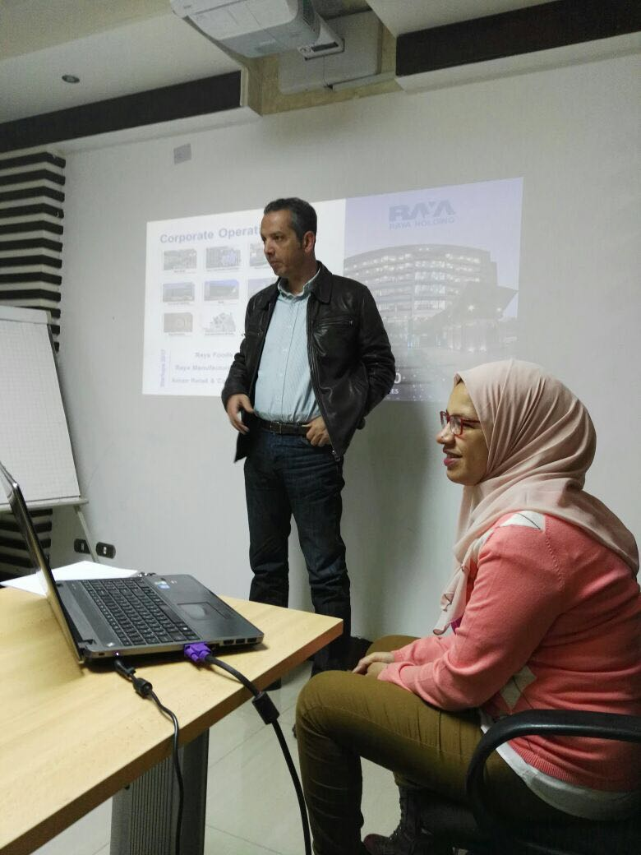
MR Mohamed during the meeting
Having new members joining our monthly meetings is a great pride for us as it’s an indicator of our community getting bigger especially this meeting we enjoyed groups from different companies. We have been using different platforms to promote our activities and announce topics of our meetings.
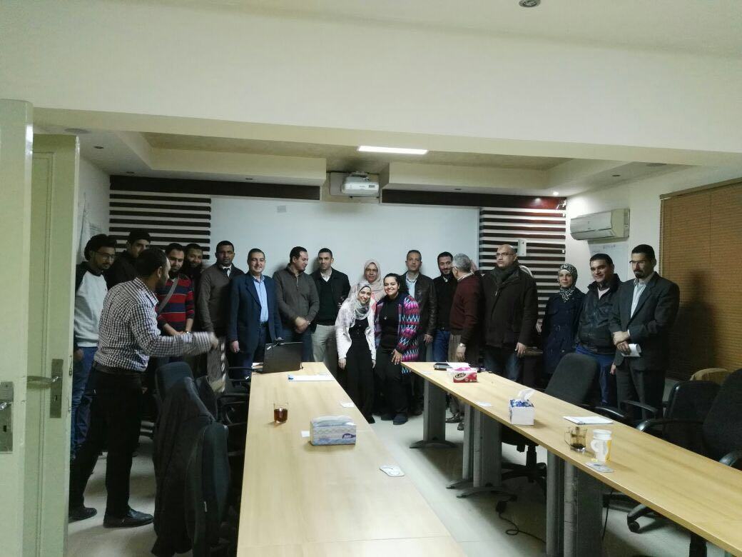
Having a strategy is important but what’s more important is to know how to apply it in the given time frame as time is the only resource that can’t be compensated.
In this meeting Shereen Mosallam and Mohamed Gamal talked about Hoshin Kanri Deployment tool and how a company Align objectives with the plans of middle management and work performed by employees to ensure that everyone is pulling in the same direction at the same time.

